Clan Wallace Society
Worldwide



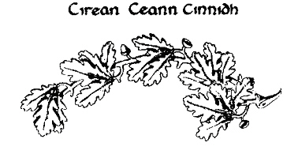

Convener Handbook

March 2010
Change Control Page

The Convener Handbook originated in 1990 by Charlie Wrenn, our past Executive Vice President. Many changes were made over the years to revise names, addresses, and add helpful guidance. A Change Control Page was added in the June 1997 revision to record the history of the updates and track changes.

1) Revision Date: June 1997
Author: Charlie Wrenn, Executive Vice President
Section(s): VIII, Appendix.
Page Number(s): 6 - 9, and 13
Summary of Change(s):
a. Page 6: Name and address changes
b. Pages 7 – 9: Sources of books and e-mail addresses added
c. Page 13: Suggested equipment checklist added
- Revision Date: June 2001
Author: Wayne Jones, Secretary
Section(s): Purpose, VIII, and Appendix.
Page Number(s): 6, 11.
Summary of Change(s):
a. Throughout: Font changed to Times New Roman
b. Purpose: Address changed to Secretary
c. Page 3: Item regarding Manrent removed
d. Page 6: Name and address changes
e. Page 10: Manrent verbiage removed
3) Revision Date: July 2002
Author: Wayne Jones, Secretary

Section(s): Sections I and II, and Appendices
Summary of Change(s):

- Throughout: Minor verbiage changes
- Sections I & II: Updated - Availability of the Society’s Convener Kit
- Appendix: 1) Convener Kit Contents List
2) Sources of Scottish Fair List
4) Revision Date: April 2004
Author: Wayne Jones, Executive Vice President

Section(s): Purpose, IV, V, IX, XI, and Appendix
Summary of Change(s):
a. Purpose: Officer and e-mail references changed.
b. Page 2: New - Planning
c. Page 3 New - Interactions With Visitors

d. Page 4: 1) Follow-up Letters and Games Reporting
2) Convening Expenses
e. Page 5: Membership Chairman’s address information
f. Page 6: President’s address information
g. Page 16: Contents of Convener Kit
5) Revision Date: January 1, 2006
Author: Wayne Jones, Director of Special Projects
Section(s): Section XIII and Appendices
Summary of Change(s):
a. Page 7: New - Membership Structure
b. Page 11: Revised verbiage in Follow-up Letters
c. Page 13: Depiction of New Membership Form
6) Revision Date: March 2007
Author: Wayne Jones, Executive Vice President
Section(s): Page changes.
Summary of Change(s):
a. Page 6: Revised - Subsections “B” and “C” to reflect the free book membership promotion for Life and Council Members.
b. Page 7: Listing of the new President.
c. Page 11: New - Sample Visitor Follow-up Letter to reflect the free book
promotions for Life and Council Members.
d. Page 13: New - Membership Form reflecting free book promotions for Life
and Council members.
e. Page 17: New - Convener Kit List
7) Revision Date: January 2009
Author: Bob Wallace, Executive Vice President
Wayne Jones, Director of Special Projects
Sections: Page changes and additions.
Summary of Changes:
a. Full Document: “Convenor(s)” to “Convener(s)” throughout
d. Section I: Revised - Reference Materials
c. Section II: Revised - Tent and Equipment
d. Section IV Revised - Planning
e. Section VI: Revised - Organizing Your Tent
f. Appendix "B" Suggest Reading List
g. Appendix "C" Example Tent Arrangements
h. Appendix "F" New - Membership Form
c. Appendix "J": Revised - Convener Kit Contents List
d. Appendix "K": New - Wallace Print Order Form
e. Appendix "M": Revised Name Tag Form
8) Revision Date: March 2010
Author: Wayne Jones, Past Director
Sections: Page changes and additions.
Summary of Changes:
a. Full Document: Numbering scheme changed
b. Section 1: New - Introduction
c. Section 2.1: Revised - Tent and Equipment
d. Section 2.3: Revised - Planning for Convening
e. Section 4: Revised - Interactions With Visitors
f. Section 4.1: Revised - Follow-up Letters
g. Section 4.2: New - Games Reporting (made separate from 4.1)
h. Appendix "D": Revised - Example Follow-up Letter
i. Appendix "F": Revised - Membership Form
j. Appendix "G": New - Rewards Program Brochure

PURPOSE

This Handbook was written to assist new Conveners in sponsoring a Clan Wallace Society tent at Scottish Games, Celtic Festivals, and Gatherings, and in promoting and expanding the membership wherein funds can be raised to assist in fulfilling the Society's missions and goals. It will, hopefully, instill a sense of ownership in the Society and its traditionally historical values, missions and goals.

In order to maintain centralized management and quality of Convener Handbook content, suggestions for changes or additions to this Handbook should be sent to the Director of Convener Affairs (DCA). The current DCA is:

Jean R. Wallace
3005 Ridge Pass Road
Little Rock, AR 7227-2123
Phone 501.227.7116

E-mail: jrwallace6@sbcglobal.net

The Director of Convener Affairs will review suggestions and make recommendations to the Executive Vice President and the President in cases where changes should be made.

The President’s current address is:

Robert Bruce Wallace, President
Clan Wallace Society - Worldwide
1500 Riverpark Parkway

Dayton, NV 89403-6374

NOTE: The Society Officers, Membership Chairman, and Program Director names and addresses are subject to change with each Board of Directors election. Please refer to your Newsletter or clanwallace.org for current information for the Owner of these offices.

NO CHANGES SHALL BE MADE TO THIS HANDBOOK WITHOUT THE PERMISSION AND APPROVAL OF THE EXECUTIVE VICE PRESIDENT AND THE PRESIDENT.

TABLE OF CONTENTS
1. INTRODUCTION Page 1
2. GETTING STARTED Page 1
2.1 Tents and Equipment Page 2
2.2. How You Should Dress Page 2
2.3 Planning For Convening Page 3
3. SETTING UP FOR CONVENING Page 3
3.1 Organizing Your Tent Page 3
3.2 Hospitality Page 4
4. INTERACTIONS WITH VISITORS Page 4
4.1 Follow-up Letters Page 5
4.2 Games Reporting Page 5
5. CONVENING EXPENSES Page 6
6. LOCAL ACTIVITIES Page 6
7. SPECIAL CONSIDERATIONS Page 6
8. MEMBERSHIP STRUCTURE Page 7

APPENDICES
Appendix "A" Books and Publications Page 9
Appendix "B" Suggested Reading List Page 12
Appendix "C" Example Tent Arrangements Page 14
Appendix "D" Example Visitor Follow-up Letter Page 15
Appendix "E" Example Response Letter for Games Invitations Page 16
Appendix "F" Membership Application Page 17
Appendix "G" Rewards Program Brochure Page 19
Appendix "H" Visitors Registration Form Page 22
Appendix "I" Scottish/Celtic Event Data Sheet Page 23
Appendix "J" Equipment Checklist Page 24
Appendix "K" Convener Kit Contents List Page 25
Appendix "L" Wallace Print Order Form Page 26
Appendix "M" Convener Source List Page 27
Appendix "N" Clan Wallace Society Name Tag Order Form Page 28

1. INTRODUCTION

The Clan Wallace Society (CWS) was formed in the State of Texas in April 1966. The purposes of the Corporation are educational, with particular reference to the history of Scotland, its public figures such as Sir William Wallace, the national hero of Scotland who suffered martyrdom for his country in 1305, and with particular reference to writings for publications, including the reprinting of articles and books now out of print concerning the history of Scotland, and particularly to the Clan and Family of Wallace, and with particular reference toward the collection, restoration, and preservation of places and objects of interest to the public generally, and particularly to the Clan and Family of Wallace.

These educational functions are carried out with the clear understanding that the results thereof will be made available to the public in general, and particularly to the Clan and Family of Wallace, for their better education concerning the subject matter, and provided further that no private individual shall ever benefit directly from such acts.

Through membership recruitment, Rewards Program contributions, and the sale of Society books, CWS obtains the necessary funds to accomplish these educational goals. These funds enable the Society to continue reprinting of books out of print, such as the Book of Wallace by Rev. Charles Rodgers; The Clan Wallace, 3rd Edition; The Wallace Family in America; and The Wallaces of Elderslie. The funds also allow the Society to make monetary contributions to assist in the restoration and preservation of worldwide Wallace and Scottish History-related places and objects, the major reason the Society was formed in 1966 as a non-profit corporation. In its first project, CWS raised funds for the purchase of five bronze (colored) plates to complete the Wallace Monument in Elderslie. The plaques were placed in 1970. Many other examples of subsequent projects can be found in the Rewards Program brochure.

As Conveners, you are the front line ambassadors in obtaining Society funds. At Celtic Festivals and Scottish Games, you have personal contact with current members and potential new members. You have the perfect opportunity to ensure the continual flow of these funds by recruiting new members, and informing them (and current members) about the worldwide projects CWS has contributed to as a result of their membership fees and Rewards Program donations.

2. GETTING STARTED

The Society has assembled a Convener Kit to help new Conveners prepare for representing the Society. The Kit contains membership forms, brochures, and many flyers containing information on Sir William Wallace. The Kit can be bought at a great Scottish savings, or can be borrowed until Conveners can build their own collection of materials. (Many items are available from the Director of Convener Affairs as outlined in Appendix "K".)

New Conveners who choose not to buy a Convener Kit should obtain books on the history of Scotland (questions are not always about Clan Wallace), and a biography of Sir William Wallace. Because many visitors ask about their name and Clan affiliation, the "Tartan for Me" (book of Scottish surnames), and a book containing Scottish Tartans should also be purchased. If you cannot answer visitor questions, it is hospitable to point them to the Festival Tartan Information Tent. Another good idea is to have a copy of the "Highlander" and/or "Scottish Life" magazine's "Games and Festival" issue, so visitors can see those schedules throughout the year. Also refer them to the Clan Wallace website, where they can choose the links to COSCA; then ASGF for games schedules.

2.1 TENT AND EQUIPMENT

To set up a Wallace tent, only a small amount of equipment is required. Although tents, tables and chairs can be rented at most Festivals, it is more economical over time to purchase them. At a minimum, the Clan tent display must include a sign-in log, Membership Forms, and the Wallace Tri-Fold Brochure. They should be prominently displayed, and be immediately available and easily accessible.

Everyone usually owns lawn chairs. Card tables, although small, work as a temporary measure. Office Max has a plastic 6-foot bi-fold table for about $70. Costco and Staples also have 4’ and 6’ heavy-duty tables for about $60. Other styles of tables are also available. If you don’t have a tent, a nylon tarp is recommended. Tie it down tightly to contend with summer storms and high winds. The 10' x 10', or 10' x 15' sizes are most practical.

Tent poles can be made from electrical conduit cut to size to fit your car. Join them with hardwood dowels sanded to fit easily into the upper sections. Purchase nylon cord for attachment to stakes. Aluminum poles available for sale in sporting goods stores often bend and do not withstand wind very well. Make the poles long enough to give ample clearance at the front of the tent so people won't have to bend to enter. A center ridgepole, higher than the front and rear, affords more comfort for standing. It also prevents water from gathering during rain.

Large plastic boxes with tops that seal can be used for tent materials, books, etc. If you don’t have plastic boxes, cardboard boxes painted red or yellow and sealed with exterior varnish will work temporarily. Use anything to keep your books and other materials from getting wet; even plastic garbage bags wrapped around cardboard boxes will work.

At the end of first day of a two-day Festival, pack materials in the boxes, including flags, place them under the table, and cover the table with a tarp large enough to extend to the ground all around the bottom of the table. Stake the tarp to the ground. This will keep the table from being blown over by wind and protects the materials from dew and rain. If you leave the American flag standing overnight, it should be lighted.

2.2 HOW YOU SHOULD DRESS
It is highly recommended that you have a kilt made before you sponsor a Game. The kilt will last a lifetime. An inexpensive way to clean it is to open it fully, pin it to the clothesline and use the garden hose to wet it thoroughly. The weight of the water pulls the pleats perfectly. If soiled, use waterless hand cleaner (such as GO-JO). Work it into the fabric and rinse well. Professional cleaners will charge $25 to $40 to clean a kilt, but telling them that it is a ladies skirt may save on cost.
2.3 PLANNING FOR CONVENING
Contact the Society Webmaster early in the year. Provide a list of events at which you will be convening during the Festival season so they can be added to the list of Games on the Society's Website. Register with the Clan Coordinator of Games and Celtic Festivals early to ensure Clan Wallace is included in the festival program.

One week before a Celtic Festival or Scottish Games, review your supply of flyers, brochures, and forms to make sure you have enough for visitors. Add a copy of the current Newsletter. Make sure all flyers and brochures are current and reflect residing officers and key contacts. This will give you time to copy flyers before departing. Stage tent display materials in an open area to make sure you have everything you want to take along. Review items against the Equipment Checklist in Appendix "I". Check them off as you load them into your vehicle. Finally, keep a count of depleted flyers during the Games so they can be restocked when you return.

3. SETTING UP FOR CONVENING
If you rent equipment at Games, it should be set up when you arrive. All you need do is arrange your tent display. When you use your own tent equipment, there are a few things to consider. If you set up on the morning of the Games day, keep in mind that most Games coordinators will want vehicles off the grounds by 8 to 8:30 a.m., even if the gate does not open to the public until 10 a.m. This means that you must be dressed, have had your breakfast, and get there early and be set up in order to meet this time requirement. Remember that it will take more time if it’s raining. The good news is that most coordinators will allow you to set up in the afternoon the day prior to the Games, which makes it very convenient. You can set up your tent, flagpoles, and unload your tent materials and cover them with a tarp until Games day the next morning. This will allow you ample time on the morning of Games day to have breakfast, clean up, dress, and arrive at the Games before the gates open to the public. When you get there, all you need do is unpack your materials and set up your tent display.

3.1 ORGANIZING YOUR TENT
Many Conveners place tables at the front of the tent, but putting them along the inside walls makes the tent more inviting for visitors. On the table should be current Society brochures, books and a visitor register. The register can be made with a binder and copies of the sign-in sheets in Appendix "G". Have some items to use as paperweights. Painted rocks are fine and are great for holding down papers, or you can cover half bricks with Wallace Tartan. Do not use the table at the front of the tent for food or drink because that may put you at risk of getting materials soiled. Eat at the rear of the tent. A card table serves that purpose well. Appendix "C" depicts three example tent arrangements. Other ideas on tent arrangements can be found in the Newsletter in the Convener reports.

Flags are great but not a necessity at your first Game. Buy equipment, books, weapons, and other display articles over time to ease the burden of cost. Flagpoles can be made from closet poles, dowel rods, or items discussed in Section II, to cut expense. Tartan flags can be made from one yard of fabric. Sew a side seam to fit over the dowel and secure it with tacks. The American flag (The Maple Leaf or provincial flag in Canada) is usually displayed. The St. Andrews flag, is available at Scottish-Irish stores or from vendors at Festivals, and is also available in the Convener Kit. Although some Clan Societies display the red and yellow Scottish Royal Flag (Rampant Lion), it is not proper
etiquette to do so. There are now flags that look similar (Colors are different), and these can be displayed. Remember that looking in at the front of the tent, the American flag goes on the left, and the St. Andrews flag goes on the right. In Canada, the Canadian flag goes on the left.

Clan badges and signs can be made from wood. They are also nice to carry in the Parade of Tartans. Use your imagination and the possibilities are endless. The Society offers a Wallace Clan Badge Flag through the Director of Convener Affairs (see the Convener Kit Contents List). A word of warning; if the Clan Chief's Coat of Arms is displayed, there must be a sign to indicate that it is his, and not yours. Coats of Arms are personal property and for the exclusive use of the person to whom they belong. In Scotland, it is unlawful to display or wear someone else's Coat of Arms. Only the Clan Badge (shown on the cover of this handbook) may be worn or displayed by Clan members. Only when the Chief is present at a Game can you fly his banner bearing his Coat of Arms.

3.2 HOSPITALITY

Games are friendship activities. If allowed in the state in which Games are held, it’s a good idea to have a bottle of Scotch and some beer so you can offer refreshment to fellow Clansmen and visitors from other Clans. If a Pipe Band plays at your tent, it is customary to offer the Drum Major and Pipe Major some Scotch or beer. But be discreet. Some Games held on public property (schools and parks) do not allow alcohol, so check local regulations. Don't forget the non-drinkers and have some soft drinks or iced tea. You can also provide snacks if you desire.

4. INTERACTIONS WITH VISITORS

The primary purpose of this Handbook is to assist Conveners in becoming more knowledgeable in the aspects of convening, and enable you to welcome Wallaces and visitors and encourage them to become part of a wonderful family of lifelong friends. Their membership fees will help the Society fulfill its missions and goals and promote the traditional purposes set forth by the founders.

Become familiar with the Society's website so you can inform visitors and Wallaces where they can find information on Games in which CWS will be participating, what information is available online, and dates and places for future Wallace Gatherings. Inform them that the website contains historical information about Sir William Wallace, the Family of Wallace, the Society, links to other sites, and that the Members Page contains a listing of Society Officers, Conveners, a picture album, the Society Games schedule, and a Membership Application.

Tell them about the membership promotions, benefits of being a member, and about the great traditional and historical spirit of the Society. Explain the educational purposes of the Society and how tax-deductible donations made through the Rewards Program will help restore, conserve, and maintain places and objects of Wallace and Scottish historical interest. Explain to them that they do not have to be a Wallace to be a member of Clan Wallace. Give them a copy of the Rewards Program brochure so they can see the projects that Society has supported with membership fees and donations.
First impressions mean a lot when it comes to recruiting new members, and the Clan Wallace Society has a reputation of being helpful. Always greet visitors with enthusiasm and introduce these prospective members to the other folks at your tent. Make them feel like part of the Wallace family.

Some visitors may only be curious and want to see your displays. Others will want to know if their surname is Scottish, or to which Clan they belong and which Tartan they can wear. Others will want to know about Sir William Wallace, Scottish history in general, or any number of subjects. Ask them if you can help them find what they are looking for even if they are from another Clan. Invite them to become members of Clan Wallace. If they ask a question that you cannot answer, have them sign the visitor register and put their question in the comments. Tell them you will research the answer and get back to them. None of us are experts on all the subjects about which visitors will ask. You can always contact fellow Conveners or members or the Board of Directors for the answer.

Always keep membership applications on hand and visible at Games because they are often requested. If they are given to a visitor, make sure a note of it is made on the sign-in log and word the follow-up letter accordingly. The membership form will be the form potential new members will use to join the Society

4.1. FOLLOW-UP LETTERS

It is highly recommended that a follow-up letter be sent to visitors promptly after the Games to thank them for their interest in the Society (see Appendix "D"). This is a matter of Society courtesy, and it gives Conveners another opportunity to invite visitors to become a member. Inform them of other upcoming Games and Festivals in their region. Since the visitor probably got the tri-fold pamphlet at the Games, don’t send them another one with the follow-up letter. Always send them copies of the Membership Application.

4.2 GAMES REPORTING

Provide a report on your convening activities. Send a short, newsy article in Word format, with photos in .jpg format as separate attachments, to the Newsletter Editor about the Games at which you convened. This will let the membership know about the Games you convene, and let them see you, your helpers, and some of the visitors at your tent. You can obtain a sample Games report from any Newsletter.

If visitors are from outside an area where you convene, check to see if there is a Convener in their area. You can let the visitor know about this convener through your follow-up letter. If there is a Convener from the visitor's area, let that Convener know so they can make contact and encourage them to become a member of the Society.

5. CONVENING EXPENSES

The Clan Wallace Society does not provide financial aid, and you do not receive any direct (material) benefit from setting up a Wallace tent. The Society was formed for the purposes of promoting the Wallace heritage and historical education. It is non-profit and exempt from Federal Income Tax under section 501 (c) (3) of the Internal Revenue Code as granted in June 1966. Some of your expenses may be deducted from your Federal, and from some State, income taxes. Keep records of anything you purchase for use at the Game.
The list below contains examples of deductible expenses:
- Convener Kits
- Fees charged to set up at the Games
- Clan tent materials (tent, tables, flags, flagpoles, banners, books, posters, Scottish period swords and weapons)
Please consult with your accountant to determine and assure expenses are deductible. Conveners can use the sample Scottish Event Data Sheet (Appendix "H") to track Games expenses. You may get a copy of our tax-free status letter from the IRS by contacting the Director of Convener Affairs.

6. LOCAL ACTIVITIES

If you are lucky enough to have a fairly large group of members in your area, you may want to consider doing a local Newsletter. Keeping members informed of upcoming events keeps them interested. Some areas have informal meetings in pubs or homes of members. Some attend Burns Night Dinners, Tartan Balls, Pipe Band Concerts or other activities as a group. The Baltimore St. Andrews Society and the Clan Wallace Society members of that area hold a Memorial Service for Sir William Wallace at his statue in Baltimore each August on the Sunday closest to the day he was put to death. Perhaps your nearest St. Andrews Society could hold such a service at a local church with participation of the members in your area.

If you foster other activities, interest will remain high among current members. An annual picnic could be held at your area’s featured Game of the year. You may also want to retain a list of local members so you can contact them for activities, or in the event that you decide to do an area Newsletter.

7. SPECIAL CONSIDERATIONS

Games Associations may forbid the sale of items not specifically associated with The Family Wallace. Clan Wallace is a non-profit organization and is listed as such with the IRS. If items such as crafts containing the Wallace Tartan are donated, they can be sold to offset the cost of the Games or equipment. Conveners need to check the ruling at each Game. Some are more lenient than others. Most critical is the IRS rulings for non-profit organizations. It must be understood that items sold from Wallace tents are sold by individuals, not the Society.
8. MEMBERSHIP STRUCTURE

Membership in the Society shall be available to all persons worldwide, regardless of age, race, heritage, or sex. The memberships in this Corporation are not transferable or refundable. All membership fees and contributions to Clan Wallace Society are tax deductible. The LIFE and COUNCIL memberships are one-time fees; there are no additional dues ever. The Society is composed of the membership categories listed below.

A. Annual Membership
A person may become an Annual Member by proper application and contribution of $20.00 (US) annually to the Society. Annual Members will have no vote, may not nominate Directors for election, and may not hold office or serve on the Board of Directors.

B. Life Membership

A person may become a Life Member by proper application and a contribution of $175.00 (US) to the Society. Once accepted as a Life Member, no annual membership fees are required. Life Members will have no vote, may not nominate Directors for election, and may not hold office or serve on the Board of Directors. Life Members may upgrade to Council Member by proper application and an additional contribution of $175.00 (US) to the Society.

C. Council Membership

A person may become a Council Member by proper application and a contribution of $350.00 (US) to the Society. Once accepted as a Council Member, no annual membership fees are required. Council Members are permitted to nominate other Council Members as Directors for election, vote in the annual elections of Directors and in other matters as expressly provided for in these Bylaws, and hold office and serve on the Board of Directors.

D. Senior Discounts

Persons who have reached the age of 60 years will be given a 10 percent Senior Discount off the Life and Council Membership fees, and for a membership fee being paid on behalf of someone who has reached the age of 60. Seniors will not be given a discount for Annual Membership, or for memberships that they purchase for other persons under the age of 60 years.

E. Honorary Membership

The President and the Board of Directors may reward a non-member with an Honorary Membership to the Society for their contributions to Scotland, Scottish Heritage, Scottish Organizations, and to the Clan Wallace Society.

F. Grandfathered Membership
All Life and Council Members of Clan Wallace Society Worldwide who hold a valid membership on January 1, 2006, shall be “Grandfathered” into their current membership levels and shall never be required to pay annual dues. However, should a “Grandfathered” Life Member desire to become a Council Member after this date, he or she will be required to submit proper application and a contribution of $175.00 (US) to the Society.

G. Membership Promotions
The Society also offers the following membership promotions:
- 10% discount for seniors over the age of 60 years
- $20 discount for Annual member upgrade to Life membership during the first year
- $35 discount for Annual member upgrade to Life membership during the second year
- $45 discount for Annual member upgrade to Life membership during the third year
- Free copies of The Clan Wallace, 3rd Edition and The Wallaces of Elderslie to new Life members
- Free copies of the Society's four Wallace books to new Council members

Appendix "F" of this Handbook contains the Membership Application. The completed application, along with the new member’s personal check or money order, payable in U.S. Funds and made out to the Clan Wallace Society, should be sent to:

Clan Wallace Society - Worldwide
Chairman Membership Committee
4634 N Beechwood Drive
Macon, GA 31210-2304

As with Society Officers, the Membership Chairman is subject to change. You will be notified about these changes, or you can refer to the current Newsletter for any changes in addresses.

All general correspondence should be sent to:

Robert Bruce Wallace, President
Clan Wallace Society - Worldwide
1500 Riverpark Parkway

Dayton, NV 89403-6374

NOTE: As with other Society Officers, the Society President is subject to change with each Board of Directors election. Members will be notified of these changes in the Winter Newsletter.

Changes in the status of the President, Board of Directors, and Membership Chairman can also be found at the Clan Wallace Website at http://www.clanwallace.org.
APPENDIX "A"

BOOKS

The following books will be helpful, and can be purchased from Unicorn

Tartan for Me
So You Want to Wear the Kilt
Kith & Kin

Unicorn Limited
P.O. Box 397
Bruceton Mills, W. Va. 26525
Phone: (304) 379-8803
Fax: (304) 379-8923
E-mail: mcleod@scotpress.com
Home Page: http://www.scotpress.com
(Send for free catalog)

Recommended Publication - William Wallace, The Kings Enemy
Can be ordered from Barnes & Noble 1-800-843-2665
Internet: http://www.Barnes&Noble.com

PUBLICATIONS

The Highlander Magazine
P. O. Box 760
Vandalia, OH 45377 USA
1-800-607-4410
www.highlandermagazine.com

The Scottish Banner
13799 Park BLVD #271
Seminole, FL 33776-3402 USA
1-866-544-5157
www.scottishbanner.com/suscribe

The Family Tree
Odom Library
P.O. Box 1110
Moultrie, GA 31776-4809 USA
E-mail: hugh.waters@lost.com
The Scots Magazine
2 Albert Square
Dundee, Scotland, DD1 9Qj UK
E-mail: scotsmagazine@dcthomson.co.uk
Internet: http://www.dcthomson.co.uk/mags/scots

Scottish Field
P.O. Box 1
Oban, Argyll, Scotland PA34-5PY UK

Scottish Journal
P.O. Box 3165
Barrington, IL 60011 USA
E-mail: angusray@scottishjournal.com
Internet: http://www.scottishjournal.com/

Scottish Life Magazine
P.O. Box 403
Vandalia, OH 45377

British Heritage
P.O. Box 8200
Harrisburg, PA 17105-8200 USA

Celtic Heritage
Clansman Publishing, Ltd.
P.O. Box 8805
Station A
Halifax, NS B3K 5M4 Canada
http://fox.nstn.ca/~celtic/

Scottish Tales Magazine
15 Vley Road
P.O. Box 2388
Scotia, NY 12302-0388 USA
E-mail: scotia.publishing@worldnet.att.net
Internet: http://www.clan.com/publishing/scotia

U. S. Scots
P.O. Box 20217
E-mail: dlaird@infinet.com
Internet: http://www.infinet.com/~dlaird/usscots/usscots.html

Scots, The Journal of the Scots Heritage Society
P.O. Box 2693
Moultrie, GA 31776-2693

APPENDIX "B"
SUGGESTED READING
RECOMMENDED READING
Title | Author | Publication Information | ISBN #
Wallace, The | Nigel Tranter | Edinburgh: 1975 | 0-340-21237-3
William Wallace: The King's Enemy | D.J. Gray | (Barnes & Noble, New York: 1991) | 0-7607-0226-8

WALLACE REFERENCE
Title | Author | Publication Information | ISBN #
Authentic Life of Sir William Wallace | Compiled from the Best Authorities | L.G.M.G. (Unicorn Limited).
Blind Harry's Wallace | William Hamilton of Gilbertford | Elspeth King, ed. (Luath Press, Edinburgh - 1998) | 0-946487-33-2
The Book of Wallace | Dr. Charles Rogers - 1889 | Reprinted by the Clan Wallace Society Worldwide
Braveheart | Randall Wallace. | Pocket Books, New York: 1995 | 0-671-52281-7
Life of William Wallace, Hero of Scotland | James Paterson | William P. Nimmo, Edinburgh
On The Trail of William Wallace | David Ross
Scotland's Bravest Knight | Seumas MacThomais | Unicorn Ltd., Bruceton Mills, WV: 1995
Stray Leaves: An English History of Sir Wm. Wallace | Charles Gordon Glass | 1873 – Publisher Unknown
The Wallace and The Bruce Restudied | J.T.T. Brown, ed | Bonner Beitrage Zur Anglistik Herausgegeben Von Prof. Dr. M. Trautmann HEFT VI
Tales of Sir William Wallace | Tom Scott | Gordon Wright Publishers, Edinburgh: 1997 | 903065-89-4
Wallace: A Biography | Peter Reese | Canongate Press, Edinburgh: 1995 | 0-86241-607-8
William Wallace | Andrew Fisher | John Donald Publishing, Edinburgh: 1988 | 0-85976-154-1
William Wallace: A Scot's Life | Glenn Telfer | Argyll Publishing, Argyll: 1995 | 1-874640-46-7
William Wallace: Brave Heart | James MacKay | Mainstream Publishing, Edinburgh: 1996 | 1-85158-823-X
William Wallace Man and Myth | Graeme Morton | Sutton Publishing Limited Printed and bound in England by J.H. Haynes & Co. Ltd, Sparkford
Your Clan Heritage: Wallace | Alan McNie | Cascade Publishing Co., Jedburgh, Scotland: 1986
Sir William Wallace |  | Geddes and Grosset as part of their Pocket series on Scottish Heroes

GENERAL INTEREST TITLES
Title | Author | Publication Information | ISBN #
Scots Kith & Kin |  | Harper-Collins Publishing, Glasgow: 1953 | 0-00-435665-9
Scottish Clan & Family Encyclopedia |  | Harper-Collins Publishing, Glasgow: 1995 | 0-00-470547-5
District Tartans | Gordon Teall of Teallach & Philip D. Smith, Jr. | Shepheard-Walwyn, London | 0-85683-085-2
Famous Scottish Battles | Philip Warner | Barnes & Noble, New York: 1975 | 0-7607-0004-4
Identifying Guide to Clans & Tartans | Blair Urquhart | Chartwell Books/Quintet Publishing, London | 0-7858-0050-6
Scottish Clan and Family Names: Their Arms, Origins and Tartans | Roddy Martine | Trafalgar Square: 1993 | 1851-58418-8
The Scottish: 100 Portraits of History's Most Influential Scots | Duncan A. Bruce | Carroll & Graf Publishers Inc., New York | 0-7867-0770-4
The Mark of the Scots | Duncan A. Bruce | Carroll & Graf Publishers Inc., New York | 0-8065-2060-4
So You're Going to Wear the Kilt! | J. Charles Thompson, FSTS | Lang Syne Publishing, Glasgow: 1979 | 185217-126-X
Tartan For Me! - 8th Edition | Dr. Philip D. Smith | Heritage Books Inc., Bowie, Maryland | 0-7884-3318-0
Story of a Nation, Scotland, A Concise History | P. Hume Brown | 1908, 1990 (Revised)
Scotland for Beginners | Jeff Fallow | 1999
Culloden | John Prebble | 1961
The Highland Clearances | John Prebble | 1963
Glencoe | John Prebble | 1966
Periods in Highland History | I.F. Grant & Hugh Cheape | 1987
Born Fighting, How the Scots-Irish Shaped America | James Webb | 2004
A Dance Called America, The Scottish Highlands the United States and Canada | James Hunter | 1994, 1996, 1997, 1999, 2000, 2002, 2004
How The Scots Invented the Modern World | Arthur Herman | 2001
The Scotch-Irish | James G. Leyburn | The University of North Carolina Press
Scotland, A new History | Michael Lynch | Century Ltd. London England – 1991  (Now PIMLICO of London)
How Scots Created America | Alastair Connell | June 2008 | 13-9781604418484

APPENDIX "C"
Three Suggested Clan Tent Arrangements

Open Area | Typical Tent Layout With Table in Front of Tent  Entry Blocked  Could be Considered Uninviting

Front of Tent

Open  Area | Tables on Sides of Tent  Has Appearance That is  Open and Inviting

Front of Tent

Three Tables, But Still
Has Appearance That is
Open and Inviting

Front of Tent

These are a few examples of how you can set up your Clan Tent. They are suggestions and are not meant to infringe upon your creativity as to how you would like your tent display to appear.
APPENDIX "D"

Example Visitor Follow-up Letter

(Date)
(Name)
(Address)
(City, State, Zip Code)
Dear (Name of Visitor),
The Clan Wallace Society - Worldwide (CWSW) would like to thank you for visiting our tent at the (Name of the Celtic Festival or Scottish Games) on (date). We enjoyed your visit and hope you received a good introduction to our Society and the Wallace Family heritage.

We would like to invite you to become a member of our Society. We have three membership types: 1) Annual Member - $20 US Funds annually; 2) Life Member - $175 US Funds; and 3) Council Member - $350 US Funds. The Life and Council memberships are one-time fees. Life and Council Members pay no annual dues, ever. As a bonus, Life Members receive The Clan Wallace, 3rd Edition and The Wallaces of Elderslie free, and Council Members receive all four Books of Wallace free for joining. There are also cost-saving incentives when Annual members upgrade to Life within the first 3-years Annual membership. Upgrade from Life to Council Member can be done at any time. Remember that the CWSW is a non-profit Corporation, so your membership fee is tax-deductible (if you itemize on your taxes) excluding the value of services received. Membership fees also assists the Society in its many Scottish history-related projects.

A Clan Wallace Society membership is also a grand idea for a birthday or Christmas gift, so I have enclosed additional membership forms for your convenience. I have also enclosed some Wallace flyers for your reading pleasure. If some are duplicates of what I gave you at (name of Game), please share them with family and friends.

I would also like to inform you of the upcoming Games that I think you would enjoy (provide location of future Games in their region). You may also want to check out the Clan Wallace Website at http://www.clanwallace.org, which contains historical information about Sir William Wallace, the Family of Wallace, and the Society. The Members Page contains a listing of CWSW Officers, Conveners, a picture album, Society Games schedules, and a membership application.

Thanks again for visiting with us.

Yours Aye,
(Convener Name)
(Address)
(City, State, Zip Code)
APPENDIX "E"
Example Response Letter for Games Invitations

(Date)
(Name)
(Address)
(City, State, Zip Code)

Dear (Games Coordinator Name)

Thank you for inviting the Clan Wallace Society - Worldwide to your Celtic event. I regret to inform you that we will be unable to have a representative participate at (or I will be unable to attend) your Games on (date, year), due to (give conflict or reason for not being able to attend). Although we/I will be not able to attend this year, please keep us in mind for next year, because the Wallaces want to participate.

Thank you once again for inviting Clan Wallace. I wish you the best of luck with your Games and hope the weather will be favorable and the crowds large.

Pro Libertate,

(Convener Name)
(Address)
(City, State, Zip Code)

APPENDIX "F"
Clan Wallace Society - Worldwide Membership Application
The following three (3) categories of Membership are available in the Clan Wallace Society.
- ANNUAL Members – those contributing $20.00 US Funds each annually to the Corporation.
- LIFE Members - those contributing $175.00 US Funds each to the Corporation.
- COUNCIL Members - those contributing $350.00 US Funds each to the Corporation.

(THE CLAN WALLACE SOCIETY IS A 501(c)(3) CHARITABLE ORGANIZATION. YOUR CONTRIBUTION IS TAX DEDUCTIBLE, EXCLUDING THE VALUE OF SERVICES AND GOODS RECEIVED.)

LIFE and COUNCIL are one-time membership fees with no annual dues. COUNCIL Members have the right to run for the Board of Directors and vote in the annual elections. All memberships are non-refundable and non-transferable. LIFE Members receive The Clan Wallace, 3rd Edition and The Wallaces of Elderslie free of charge with membership. COUNCIL Members receive the full set of the four Wallace books free of charge with membership (the first four listed on the back.)
(See back of page for book offerings.)
We encourage you to become involved in your Society by promoting the Society, the family of Wallace, the history of Scotland, and your Scottish community. Please indicate areas of interest:

- Become a Convener at local Scottish events  Support and assist your Conveners
- Run for the Board of Directors  Serve on a Committee
- Please have a Director contact me regarding __________________________________________________
 Any other talent _________________________________________________________________________

(Please print all information clearly.)
Type of Membership:  Life  Council  Annual  Annual Renewal
Upgrade:  Upgrade to Life Membership  Upgrade to Council Membership
Payment Method:  Check  Cash  Money Order
(See back page for membership promotions.)
Name: _____________________________________________________Birth Year: __________________________
Street Address: __________________________________________________________________________________
City: ____________________________________State or Province: _______________________________________
Zip Code (9 digits): __________________________Country: ____________________________________________
Phone (Home): ___________________________ Email Address: _______________________________________ *
Date of Application: _____________________________________________________________________________
* If you have e-mail, this will be the default for Newsletter delivery.

The following publications are available for purchase. All publications are postpaid.

1. Seaver’s Wallace Genealogical Data – 1927 $15.50 
2. Mitchell’s Wallaces of Elderslie - 1884 $10.50 
3. The Clan Wallace, 3rd Edition $20.00  (Descriptions of books are
4. The Wallace Family in America $10.50  available at
5. Book of Wallace Members $60.00  http://clanwallace.org/books.html)
Non-members $75.00 
6. On the Trail of William Wallace $9.00 

Checks for books should be made out to Clan Wallace Society, and mailed to the Membership Chairman at the address below.
Membership Promotions
The Society offers several membership promotions:
- Seniors over the age of 60 receive a 10% discount for Life and Council memberships
- $20 discount for Annual members who upgrade to Life during the first year
- $35 discount for Annual members who upgrade to Life during the second year
- $45 discount for Annual members who upgrade to Life during the third year
- New Life Members will receive a The Clan Wallace, 3rd Edition and The Wallaces of Elderslie at no cost
- New Council Members will receive the first four Wallace books listed above at no cost
Please make your check, bank draft, or money order (payable in U.S. Funds) to the Clan Wallace Society. When joining the Society, payments for both membership fees and publications can be sent to:

Clan Wallace Society - Worldwide
Chairman Membership Committee
4634 N Beechwood Drive
Macon, GA 31210-2304

Convener: ________________________________ Celtic Event: _____________________________________________
Rev.5 - 2.10

APPENDIX "G"

REWARDS PROGRAM BROCHURE
The Clan Wallace Society Worldwide (CWSW) Rewards Program

Clan Wallace fulfills the principles of its Articles of Incorporation by reprinting out of date books about the history of Scotland, by collecting, restoring, and preserving places and objects of interest to the general public, especially to the Clan and Family of Wallace. An early project was the purchase of five bonze (colored) plates to complete the Wallace Monument in Elderslie, the main reason CWSW was formed in 1966. The plaques were placed in 1970.
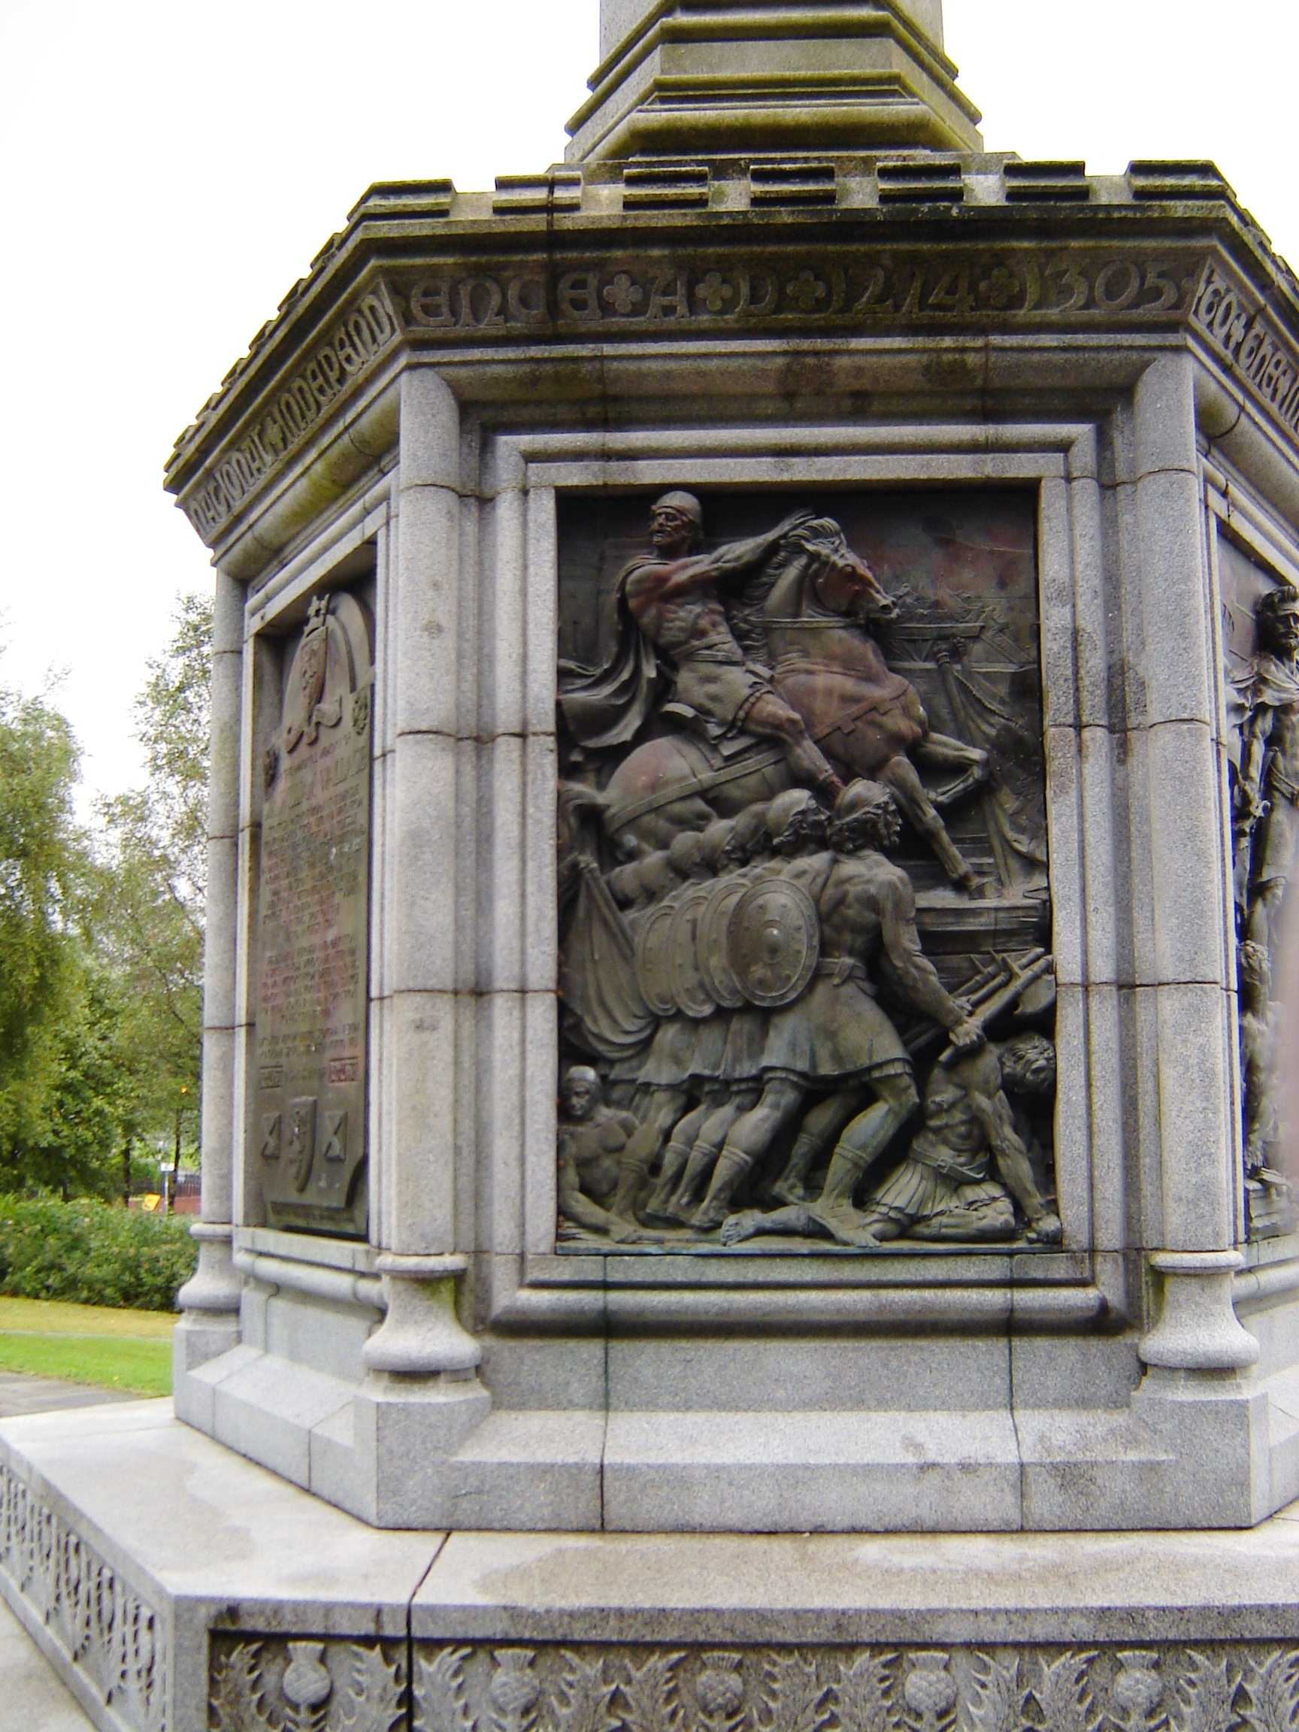

Wallace Monument in Elderslie

Clan Wallace has officially established a Rewards Program to give contributors the opportunity to assist in the implementations of its stated goals. It provides a positive method for individuals to show their support and entrepreneurial spirit, while receiving in return tangible and attractive tokens of gratitude designed specifically for our Clan Society. Donations of any size can be made, and can be tailored to an individual’s ability to give over any time period, and all contributions to the Rewards Program are greatly appreciated. Rewards are provided to the contributor as each Reward Level is reached. Larger donations that exceed other Reward levels will result in the higher Reward and all subordinate Reward Level elements being awarded, except for the Certificates. Together, we can achieve Society goals through the Rewards Program and our tax-deductible donations. Every donation, regardless of size, helps the Society accomplish its goals. We invite everyone to participate in the Rewards Program. For more information, go to www.clanwallace.org/rewards/rewards.html.
Rewards Program Administration

All donations are recorded in personal accounts for ongoing action. All donations are welcomed and are cumulative. When a person makes further donations they are recorded in their personal account and they receive those Rewards. Contributors receive a letter from the Society Treasurer acknowledging their contribution, notice of the amount that is tax deducible, and a citation of CWSW' Tax Exempt status. Contributors will also receive a Letter from the President congratulating the donor on their Reward, a Certificate, and Newsletter publicity. This tiered level of rewards was developed to thank contributors for their generosity. The five levels of Rewards are depicted at the right.
Members, non-members, and organizations may make donations to the Rewards Program by sending name, address, phone number, and e-mail addresses along with their donation checks in the name of the Clan Wallace Society Worldwide to:
John R. Wallace, Chairman
CWSW Rewards Program110
Azalea Drive
Walterboro, SC 29488-2605
Recent History of Restoration and Preservation Projects
Reward Level | Reward Level
Circle of the Thistle Lapel Pin  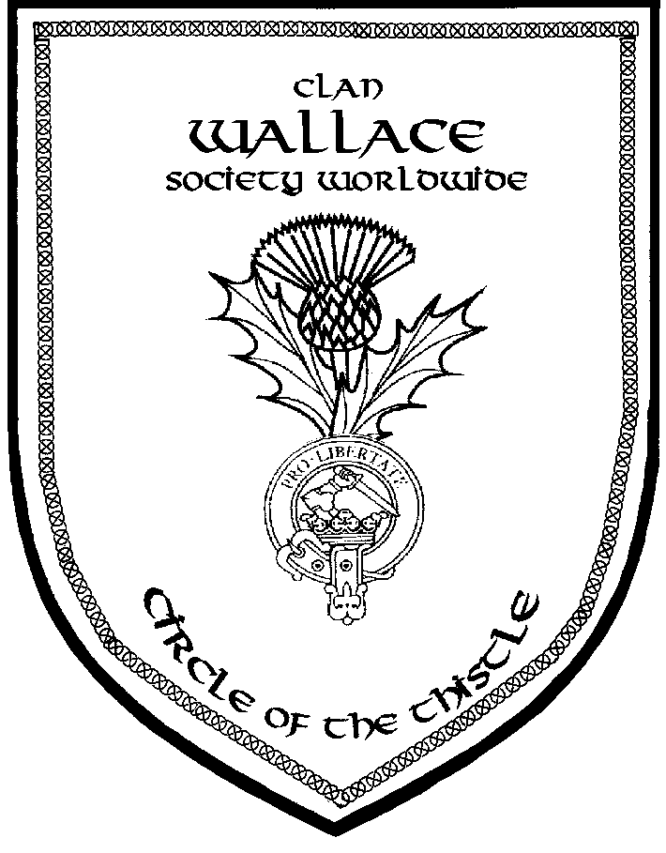  (1 1/4" tall)  $100 to $199 | Circle of the Knight Medal & Small Medal on Tartan Ribbon  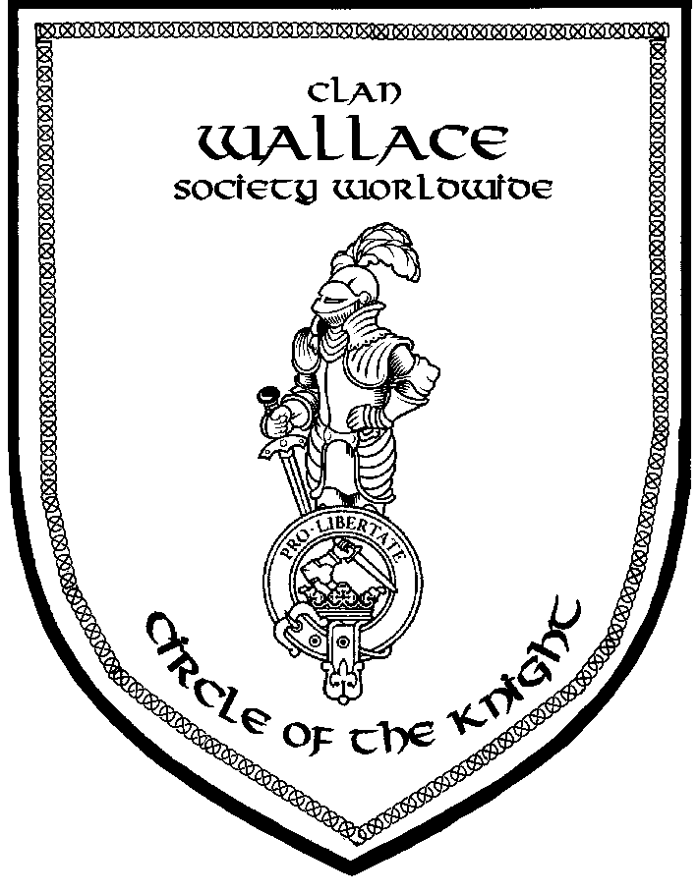  $1000 to $4999
Circle of the Cross Lapel Pin  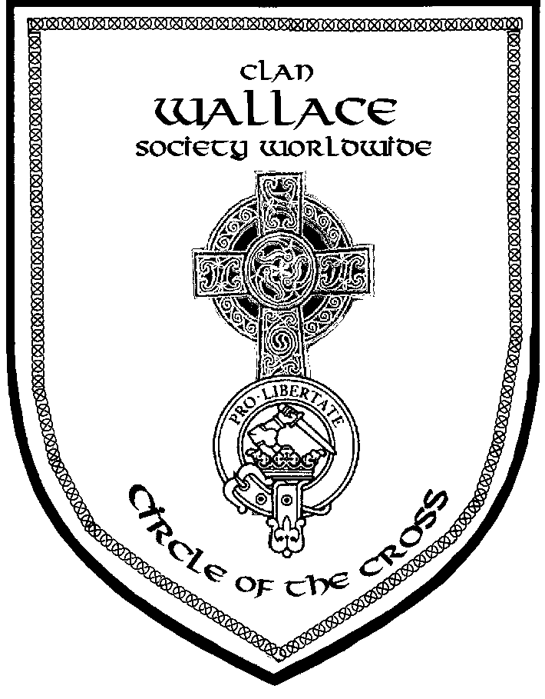  (1 1/4" tall)  $200 to $499 | Circle of Sir William Wallace Medallion on Tartan Neck Ribbon In Presentation Box  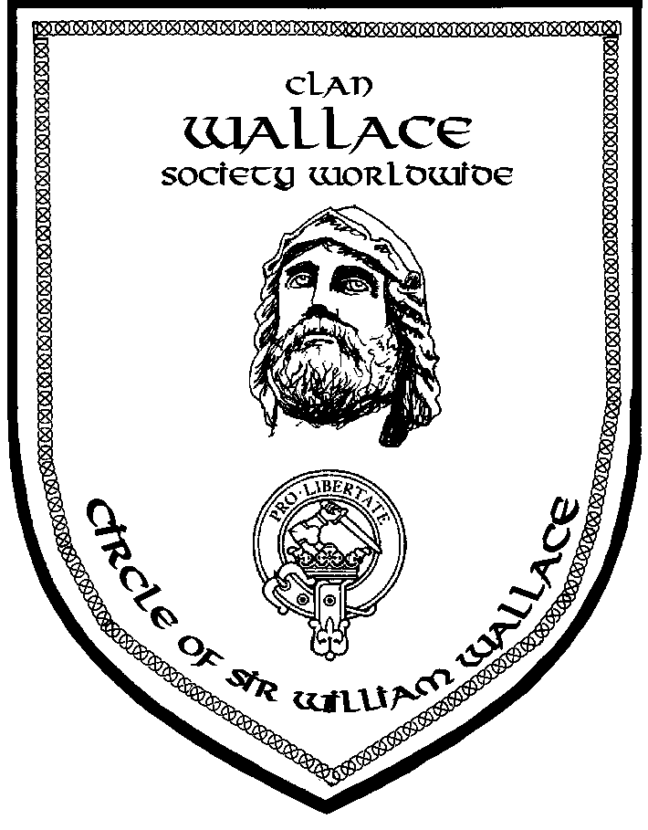  $5000 and over
Circle of the Saltire Lapel Pin
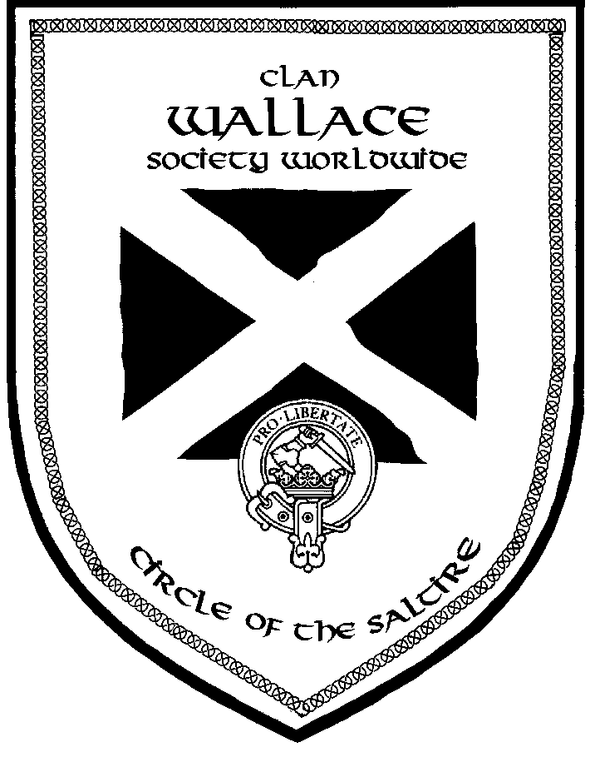
(1 1/4" tall)
$500 to $999
The following successes are a direct result of donations made to the Rewards Program:
- 2005: Donation to the Stirling Smith Museum and Art Gallery for Portrait
- 2005: Wallace Mural - Wallaceburg ON
- 2006: Donations to preserve the Wallace Yew Tree at Elderslie damaged by vandalism and lightning
- 2007/2008: Donations to support the Wallace700 Association in Aberdeen
- 2008: Wallace Walkway Paving Stone to help build the Culloden Battlefield Visitors Center
- 2008: Paving Brick at Robert Burns Statue in Milwaukee
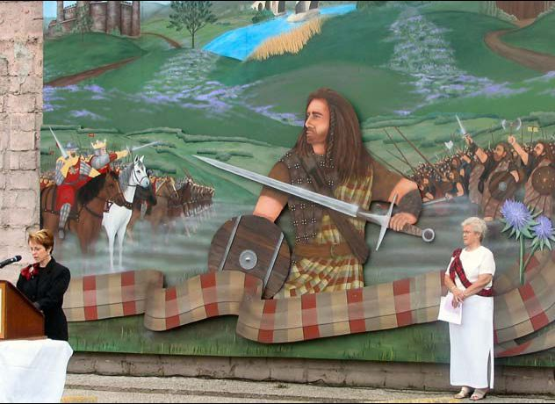

Wallace Mural at Wallaceburg ON

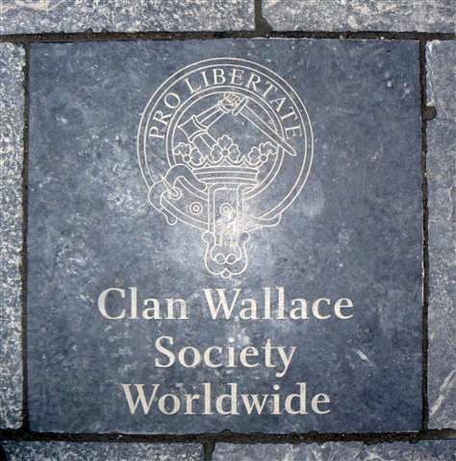
Paving Stone in the Culloden Battlefield

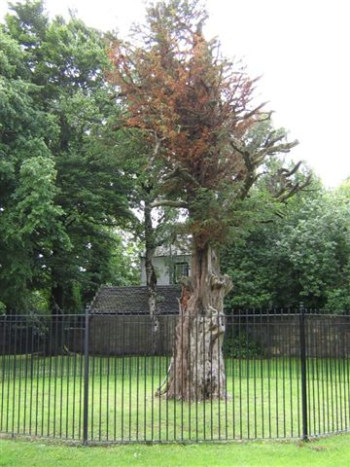
Rejuvenated Wallace Yew Tree at Elderslie

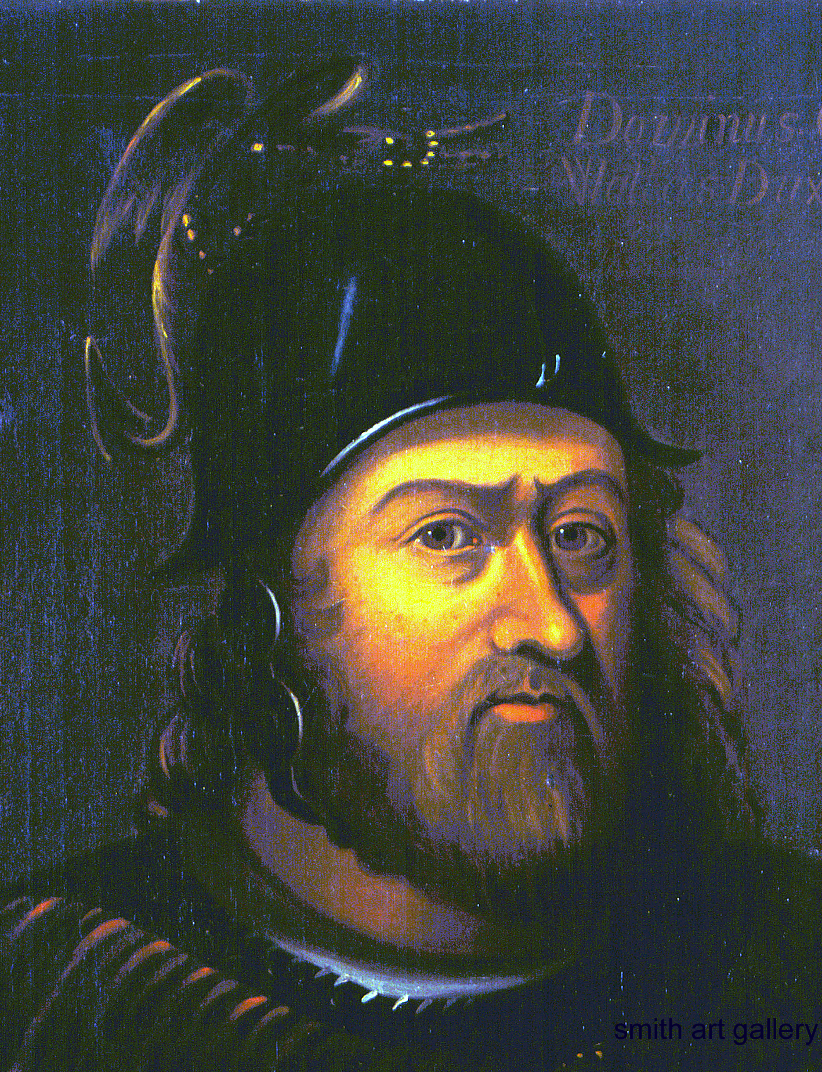
Sir William Wallace Painting at Smith Museum That CWSW Helped Purchase

Clan Wallace
Society
Worldwide

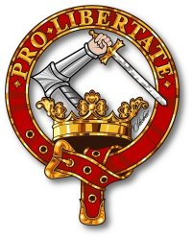

Rewards Program
APPENDIX "H"
CLAN WALLACE SOCIETY - WORLDWIDE VISITORS REGISTRATION FORM
LOCATION: ________________________________________________________________DATE:___________________

Please Print Clearly
Name: _____________________________________________________________________Member: Yes ____ No ____

Street Address:_______________________________________________________________Phone:___________________

City, State, Zip Code:__________________________________________________________E-mail:___________________

Comments:___________________________________________________________________________________________

Name:______________________________________________________________________Member: Yes ____ No ____

Street Address:_______________________________________________________________Phone:____________________

City, State, Zip Code:_________________________________________________________E-mail:____________________

Comments:____________________________________________________________________________________________

Name:_____________________________________________________________________Member: Yes _____ No _____

Street Address:______________________________________________________________ Phone:____________________

City, State, Zip Code:__________________________________________________________E-mail:____________________
Comments:____________________________________________________________________________________________

Name:______________________________________________________________________Member: Yes ____ No ____

Street Address:____ __________________________________________________ ________Phone:____________________

City, State, Zip Code:__________________________________________________________E-mail:___________________

Comments:____________________________________________________________________________________________

Name:______________________________________________________________________Member: Yes ____ No ____

Street Address:________________________________________________________________Phone:___________________

City, State, Zip Code:__________________________________________________________E-mail:___________________
Comments:___________________________________________________________________________________________

Name:_____________________________________________________________________Member: Yes ____ No _____

Street Address: ______________________________________________________________Phone:____________________

City, State, Zip Code:_________________________________________________________E-mail:____________________

Comments:___________________________________________________________________________________________
APPENDIX "I"
SCOTTISH/CELTIC EVENT DATA SHEET

EVENT NAME: ______________________________________________________________________________

EVENT DATE: _____________________________LOCATION: ______________________________________

DEPART DATE: ____________________________DATE RETURN: ___________________________________

1. LODGING

HOTEL: ______________________________________________________________________________

LOCATION: ___________________________________________________________COST: $ ____.___

2. MEALS/MISC. FOOD

DAY DATE MEAL/COST RECEIPT (circle one)

(1) BREAKFAST: $ . Y N

LUNCH: $ . Y N

DINNER: $ . Y N

(2) BREAKFAST: $ . Y N

LUNCH: $ . Y N

DINNER: $ . Y N

TOTAL MEALS COSTS: $____.__
3. TRAVEL COSTS

AUTO: ODOM MILES START: ODOM MILES END:_____________________
TOTAL MILES HOME TO HOME: @ $.xx PER MILE TOTAL: $___.__

4. GAMES COSTS (xx = tax year rate)

FEES: $ . RENTALS: $ . TICKETS: $ . TOTAL: $___.__

5. TOTAL REPORTABLE COSTS

(1) TOTAL REPORTABLE LODGING COSTS: $___.__

(2) TOTAL REPORTABLE MEALS COSTS: $___.__

(3) TOTAL REPORTABLE MILEAGE COSTS: $___.__

(4) TOTAL REPORTABLE GAMES COSTS: $___.__

GRAND TOTAL REPORTABLE COSTS $____.__

APPENDIX "J"
EQUIPMENT CHECKLIST

TENT TARTAN FOR ME

LARGE TABLE; or FOUR BOOKS OF WALLACE

CARD TABLE; and/or APRIL "HIGHLANDER" (contains Games schedules)

PICNIC TABLE WALLACE PRINTS

CHAIRS MEMBERSHIP INFORMATION SHEETS

WALLACE TARTAN TABLECLOTH LOCAL AREA INFORMATION SHEETS

FLAGS VISITOR REGISTRATION FORMS

FLAGPOLES BOOK BOX (WITH BOOKS)

HARDWARE (HAMMER, WOOD BLOCK) NEWSLETTERS

BUNGEE CORDS BUSINESS CARD HOLDER, CARDS

PLASTIC TIES or DUCT TAPE FOOD

TARPS SCOTCH

SWORD (S) BEER

CLAN BADGE FLAG ICED TEA

CLAN WALLACE BANNER (for front of tent) THERMOS JUGS

PARADE BANNER WINE COOLERS

CLAN SIGN CAMERA, CAMCORDER

TRASH BAGS AUDIO RECORDER, TAPES

ICE CHEST & ICE SNACKS

DRINKING WATER SOFT DRINKS

TENT DISPLAYS PAPERWEIGHTS

PICTURE ALBUMS WASHCLOTH & TOWEL (FOR HOT DAYS)

DISPLAY RACKS RAIN GEAR

SOCIETY BROCHURES Note: This list can be expanded to include Scottish apparel and accessories, and your specific display items.
APPENDIX "K"
Contents of Convener Kit
Provided Free by the Society | Cost
On The Trail of William Wallace - by David R. Ross | ($14.95 value) *
Making of Clan Wallace Society – by Charles B. Wallace | *
Brochure on “The Book of Wallace” – by Charles Rogers | *
Clan Wallace Society - Worldwide Marketing Brochure | *
Rewards Program Brochure | *
Uniting Wallaces Around The World (Tri-fold on Andrew Wallace) | *
Researching Wallace Family Genealogy - Bi-Fold Brochure | *
Braveheart – Fact or Fiction | *
Life Events of Sir William Wallace | *
The Wallace Beazon of Arms | *
The Wallaces (Roots) – Charles T. Wallace | *
Scottish Event Data Sheet | *
Clan Wallace Visitor Sign-In Sheet | *
Clan Wallace Society Membership Form (2 pager, front and back) | *
Clan Wallace Society Name Tag Order Form | *
Scottish Apparel Catalog (J. Higgins, Ltd. provided as example) | *
Folders for filing all flyers and forms | *

Total Mailing Cost to Convener will be determined by the Postal Service

Items Available At Cost To Conveners
The Clan Wallace – 3rd Edition | $20
Wallace Genealogical Data –1927 | $15.50
The Wallace Family in America | $10.50
The Wallaces of Elderslie – 1884 | $10.50
Wallace Tartan Tablecloth | $20
Clan Wallace Badge Flag | $32
St. Andrews Flag of Scotland | $24
Tartan for Me | $19
Clan Map of Scotland | $12
Total Cost of Convener Kit (if ordered in total) | $163.50
Other Items Available At Cost To Conveners
Wallace Prints (2 choices). a) 19”h x 25 3/4”w b) 30”h x 23”w 1/ | a) $17.00 b) $23.95
Clan Wallace Tent Banner (2’ h x 9 ½’ w) | $100.00

* Items “Provided Free by the Society” mailing cost will be determined by the Postal Service. All flyers, forms and
the Handbook are provided in hard and soft copy at no cost to Conveners.
When Conveners buy all “Items Available At Cost To Conveners” in a single order of $163.50, or with the initial Kit order, they will be mailed free of charge. When items are ordered separately, the Convener will pay the mailing cost as determined by the Postal Service. Checks for Convener Kits should be sent to the Director of Convener Affairs.
1/ a) Niddrie Marischal portrait with gold scrollwork.
b) 19th century portrait with Dragon Crest on Helmet.
c) Wallace Prints can be ordered uncovered and without grommets for the purpose of framing.
    - Wallace Prints must be ordered directly from the printer source. (See order form on next page.)
Due to special arrangements made with the Stirling Smith Museum, the Wallace prints can be offered to Conveners only for the promotion of the Clan Wallace Society and the history of Sir William Wallace and the Family Wallace.
APPENDIX "L"
CLAN WALLACE SOCIETY WALLACE PRINT ORDER FORM

Clan Wallace has two Sir William Wallace prints that were acquired from the Stirling Smith Museum. Due to special arrangements made with the Museum, the Wallace prints can only be offered to Conveners for the promotion of the Clan Wallace Society, the history of Sir William Wallace, and the Family Wallace. The two prints are the most common depictions of Sir William Wallace. Prints must be ordered directly from the printer, and checks should be made out to the printer as listed below. Checks for Wallace Prints should also be separate and not part of any payment for other Convener Kit items.

Niddrie Marischal Portrait With Gold Scrollwork
□ 19” h x 25 3/4” w - Plastic Covered & Grommets for Hanging - $17.00
□ 19” h x 25 3/4” w - Centered on 23 X 30 paper and Uncovered for Framing $25.00
19th Century Portrait With Dragon Crest on Helmet
□ 30” h x 23” w - Plastic Covered & Grommets for Hanging - $23.95
□ 30” h x 23” w - Centered on 28 x 35 paper and Uncovered for Framing – $35.00
Clan Wallace Tent Banner
□ 2’h x 9 ½’ w - Plastic Covered & Grommets- $100.00
Shipping
- For one print: Tube $2.49; Mailing $2.70; Insurance (optional) $1.70
- For both prints: Tube $3.49; Mailing $6.67; Insurance (optional) $1.70
Please allow 2 to 3 weeks for delivery.
Shipping Address:

Name: ____________________________________________________________

Address: __________________________________________________________

City: ______________________ State/Province ___________________________

Postal Code: ________________________Country: ________________________
Please mail the completed form with check or Postal Money Order in US Dollars to:

Dick Wallace Map Graphics
3005 Ridge Pass Road
Little Rock, AR 72227-2123

APPENDIX "M"
Convener Source List

The following is an example list of providers of Scottish apparel, jewelry, and books, etc. It also contains sources of other tent equipment. The Clan Wallace Society neither promotes or recommends the purchase of materials from any vendor listed, nor receives any award or compensation for listing them. The vendors listed can as easily be obtained from the many Scottish publications, such as the Highlander or Scottish Banner. We simply offer them as sources that can be used to make price comparisons. All decisions for purchase are the sole responsibility of the individual Convener.

Company | Fare | Address | E-mail | Phone #
J. Higgins, Ltd. * | Full array of Scottish apparel | P.O. Box 14341  Lenexa, KS 66285-4341 | jhiggins.net | 1-800-426-7268
Walker Metalsmiths | Celtic jewelry | One Main Street  P.O. Box 706  Andover, NY 14806-0706 | celtarts.com | 1-800-488-6347
The Highlander | Scottish Magazine | P.O. Box 760  Vandalia, OH 45377 |  | 1-800-607-4410
Geoffrey (Tailor) | Kiltmakers & Weavers |  | Geoffreykilts@  compuserve.com | 1-800-566-1467
Barnes & Noble | Books of all kinds, usually at discount prices | Check your area phone book | Barnes&Noble.com | 1-800-843-2665
Unicorn Limited | Books | P.O. Box 397  Bruceton Mills, WV 26525 | Unicorn.com | 304-379-8803
Office Max | Plastic bi-fold, 6’ tables ($70) | Check your area phone book
SAMs Club | 10’x10’ tents ($200) | Check your area phone book
Discount Chains | Lawn Chairs, etc.
Highland Line International | Clan Flag - Clan Wallace Crest on Tartan Background | 80 Carrington Drive  Richmond Hill,  Ontario L4C 7X9 | www.highlandline.com | 1-866-455-6854

* Catalogs included in the Convener Kit
APPENDIX "N"

CLAN WALLACE SOCIETY
NAMETAG ORDER FORM

Nametags are displayed online at http://clanwallace.org/cwstag/index.html. A copy of the form may be found at http://clanwallace.org/cwstag/order.htm. Multiple nametags with different names require a separate form for each nametag.

There are three colors of laser engraved nametags and one color printed nametag available. Please indicate the number and the color/style nametag wanted. Letter codes refer to the online picture.

(A)____Gold with black letters laser engraved (B) ____Color printed on white background
(C)____White with red letters laser engraved (D) ____Red with white letters laser engraved

Please PRINT legibly the wording you want on the nametag.

1st Line – Name: _____________________________________________________________________

2nd Line – ONLY if you are a CWS Officer: _______________________________________________

3rd Line – (Already specified – no substitutes!): Clan Wallace Society

4th Line – City, State or Province _________________________________________________________

Note: The Clan Wallace Society is no longer directly accepting orders for nametags.
Nametag templates are on file at Shamrock Awards, the engraving shop.
Contact them via Internet browser at: http://www.shamrockawards.com,
or e-mail to ShamrockAwards@verizon.net for additional information.

